**Electronics and Control Chapter**

**Hardware Selection and PCB Layout**

**Sensors in the Bionic Arm:**

***FSR Model:***  Force Sensitive Sensor (Film Pressure Sensor - 1kg)

***Number of Sensors:*** 5 (one for each finger)

***Price:*** 120LE per sensor at Future Electronics

***Specifications:***

* Load capacity: 0 - 1kg.
* Outer diameter: 9mm
* Sensing inner diameter: 7.5mm
* Overall length: 45mm
* Resistance Range: Infinite (no pressure) to 200Ω (max pressure)

***How it Works:***

Force Sensing Resistors (FSRs) are sensors that allow you to detect physical pressure, squeezing and weight.   
 The FSR is made of 2 layers separated by a spacer. The more one presses, the more of those Active Element dots touch the semiconductor and that makes the resistance go down. This action reduces the resistance of the sensor.

**Note:** It is advised to fix the sensor on a flat surface for consistent readings. Calibration will be needed for better accuracy.

***Reading Sensor Data:***

As seen from the concept driving this sensor operation, we can read force changes based on the change in resistance value of the FSR. This can be done by having a voltage divider circuit in which analog voltage signal enters the microcontroller. As in the following configuration, as more pressure is applied, FSR resistance decreases, and a higher voltage signal enters the microcontroller.

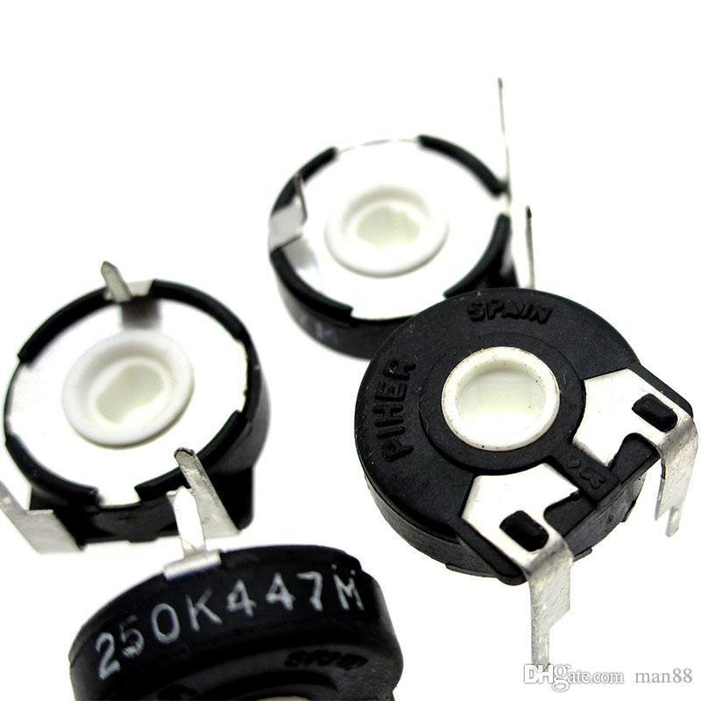**…………………………………………………………………………………………………………………………..**

***Potentiometer Model:*** Rotary Position Sensor (PIHER SPAIN)

***Number of Sensors:*** 4 (One for each knuckle)

***Price:*** 8LE from El-Amir Store

***Specifications:***

* Resistance Range: 2.5K to 10K
* Dimensions: 16mm diameter
* # of continuous rotations: 1
* Max # of cycles: 1Million

***How it Works:***

This Analog Sensor acts as a potentiometer that changes its resistance value as the shaft rotates the inner wiper. The device is used in closed loop feedback control systems with its compact design that allows for addition in limited spaces. Three terminals of the sensor represent the minimum, maximum, and current resistance value.

***Reading sensor data:***

The sensor is used by activating the ADC of the MCU. Reading data directly from the sensor is possible without the need for any hardware filtration. Although some software filtration might be needed for optimal results.

**…………………………………………………………………………………………………………………………**

 ***IMU Model:*** MPU6050 IMU “3-Axis Accelerometer Gyroscope 6DOF module. “

***Number of sensors used:*** 2

***Price:*** 95LE at RAM Electronics.

***Specification:***

* Dimensions (in millimeters): D*E*A = 4.00*4.00*0.90.
* Gyroscope features: Digital-output X-, Y- and Z-Axis angular rate sensors (gyroscopes) with a user-programmable full-scale range of ±250, ±500, ±1000 and ±2000 °/sec.
* Accelerometer features: Digital-output triple-axis accelerometer with a user-programmable full-scale range of ±2g, ±4g, ±8g and ±16g.

***How it Works:***

The MPU6050 IMU has both 3-Axis accelerometer and 3-Axis gyroscope integrated on a single chip.

The gyroscope measures rotational velocity or rate of change of the angular position over time, along the X, Y and Z axis. It uses MEMS technology and the Coriolis Effect for measuring. The outputs of the gyroscope are in degrees per second, so to get the angular position we just need to integrate the angular velocity.

The accelerometer measures gravitational acceleration along the 3 axes and using some trigonometry math we can calculate the angle at which the sensor is positioned. So, if we fuse, or combine the accelerometer and gyroscope data we can get very accurate information about the sensor orientation.

***Reading Sensor Data:***

As seen from the previous concept driving this sensor operation, we know the orientation of sensor and the object that it has been attached to based on the change in the orientation of axes of sensitivity and polarity of rotation.

We are using for communication I2C protocol for communication with the Arduino, so we need only two wires for connecting, plus the two wires for powering.

**…………………………………………………………………………………………………………………………..**

***Temperature Sensor Model:*** MLX90614 infrared temperature sensor

***Number of Sensors:*** 1 in Palm

***Price:*** 410 LE from Future Electronics

***Specifications:***

* Operating voltage: 3.3 ~ 5V
* object temperature: -70 to +380°C
* High accuracy of 0.5°C over wide temperature range
* ***Graphical user interface, diagram, schematic

  Description automatically generated***I2C interface

***How it Works:***

The temperature sensor measures the infrared radiation of surrounding objects and compares it to that of the environment. It can identify temperature without physical contact to the object, giving the bionic arm a major advantage in sense restoration for amputees. It can measure infrared emission by focusing it on a photodetector that outputs a voltage level proportional to the infrared radiation.

**Note:** the sensor requires a line of sight with the object being measured to have a path to measure infrared radiation. Also, the sensor should be slightly recessed in the palm to avoid damaging the sensor while grasping objects. Note that the sensor by itself is cheaper (at 185 LE), but the module having some amplification and communication protocols for convenience is more expensive.

***Reading Sensor Data:***

The module has 4 pins two of which are for power delivery. The other 2 are for communication (I2C) with the MCU. Pull up resistors are added in the module and no need to add them externally. Cheaper versions of the thermometer require further amplification and more electronic circuitry. Analog data read by the MCU can then be calibrated for temperature readings.

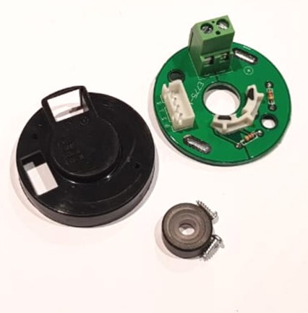***Encoder Model:*** 7PPR “MY-775” Encoder

***Number of Sensors:*** 1 in in Elbow Mechanism

***Price:*** 150 LE from RAM Electronics

***Specifications:***

* Operating voltage: 4.5 ~ 24V
* 7 pulses per revolution
* Used with 775 Standard Motors
* ***A pair of headphones

  Description automatically generated with low confidence***2 Channel Incremental Encoder

***How it Works:***

The encoder has a magnet that rotates with the motor shaft rotation. By using an array of Hal Sensors to sense the change in the magnetic field that is a result of the magnet rotation. The incremental sensor has 2 channels that are phase shifted by 90⁰ to identify the direction of rotation. To identify the speed of rotation, we measure the time between 2 pulses in one of the encoder channels.

**Note:** Generally,Interfacing the sensor is possible by using timer modules in input capture mode; However, some microcontrollers have timers operating in encoder mode that lets timer module work independently from the processor.

***Reading Sensor Data:***

The module has 4 pins two of which are for power delivery. The other 2 are for Channel A and B connected to MCU Timer pins.

**Microcontrollers in the Bionic Arm:**

***System Sensors and Actuators***

|  |  |  |  |
| --- | --- | --- | --- |
| *Category* | *Number of Units* | *Pins/Unit* | *Total MCU Requirements* |
| *UART Communication* | ***3*** | ***1 TX, 1 RX*** | ***3 TX, 3 RX*** |
| *Force Sensors* | ***4*** | ***1 Analog Pin, Power*** | ***4 Analog Pins*** |
| *IMU* | ***2*** | ***1SDA, 1SCL, Power*** | ***2 SDA,2 SCL Pins*** |
| *Rotary Position Sensors* | ***4*** | ***1 Analog Pin, Power*** | ***4 Analog Pins*** |
| *Infrared Temp Sensor* | ***1*** | ***1SDA,1SCL, Power*** | ***1 SDA, 1SCL Pins*** |
| *Servos* | ***8*** | ***1 PWM, Power*** | ***8 PWM*** |
| *DC Motor Drivers* | ***5*** | ***1PWM, 2GPIO, Power*** | ***5 PWM, 10 GPIO*** |
| *Peltier* | ***1*** | ***1 PWM, 2GPIO, Power*** | ***1 PWM, 2 GPIO, Power*** |
| *Vibration Motor* | ***2*** | ***1 PWM, Power*** | ***2 PWM, Power*** |

|  |  |  |  |
| --- | --- | --- | --- |
| *MCU Specifications and Features* | | | |
| *Analog Input* | ***20 Pins*** | ***>Core m3 32bit*** | ***>70MHz*** |
| *PWM Output* | ***17 Pins*** | ***Dev board with Flasher and FPU*** | |
| *GPIO Output* | ***18-30*** | ***Easily Available in Egypt*** | |
| *I2C Modules* | ***3 Modules*** | ***Memory is not prioritized but higher is better*** | |
| *UART Modules* | ***2-3 Modules*** |

***Selected MCU Options and Features***

**ARM STM32 Minimum System Development Board "STM32F103C8T6"**

* Package Type: LQFP
* Number of pins: 48
* Kernel: Cortex-M3
* Operating frequency: 72MHz
* Storage resources: 64K Byte Flash, 20KByte SRAM
* Interface Resources: 2x SPI, 3x USART, 2x I2C, 1x CAN, 37x I / O ports,
* Analog-to-digital conversion: 2x ADC (12-bit / 16-channel)
* Timers: 3 general timers and 1 advanced timer

3 Boards are used to control the different bionic arm modules.

**Palm PCB Layout:**

The PCB controlling the Hand module is placed in the palm. Dimensions of the bounding box of the PCB is provided by mechanical team designers and fixation hole positions. This process is critical because if excessively small dimensions were set by the mechanical team, it would be impossible to manufacture the PCB with the required electronics.

By verifying that the components can be initially set into position in the bounding box set by the mechanical team, we approve the initial PCB dimensions and start setting connections between MCU pins and sensor pins. Because we use custom made drivers to interface the MCU, we can enable alternative functions for MCU pins and not only the default peripheral pinout. This provided multiple options for configuring the pins to be used as needed based on sensor requirements.

After verifying the layout on a breadboard to make sure that all pins are connected correctly, we began to lay the components on the Eagle PCB Schematic program. It is important to set pin headers on the write side od the board to reduce wire routes as much as possible. Power Connectors, Servos, and FSR connectors are placed on the top side of the board along with the MCU “BluePill STM32 Board” and the IMU sensor. The bottom side of the board has the temperature sensor pins, motors, and other PCB passive components like resistors and capacitors necessary to filter out FSR readings “low pass filters”.

The PCB has an analog mux that we used to increase the ADC channel pin readings of the board as we needed more PWM pins than previously anticipated. 6 analog sensors are connected to the input of the MUX, and 3 analog pins from the MCU are connected to the MUX output.